Install terraform first
Create a folger mkgir my file
Cd file/
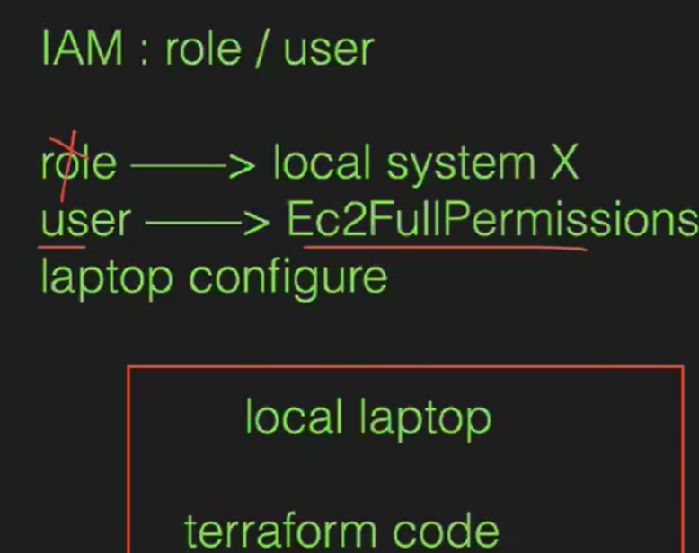

Create, tf file 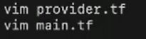
Resources
Indatation means file wilw create after this ise cmd terraform fmt use this cmd FTWER WILL CHanfe .tf file format
Main.tf and state file uses its stored the live infra to store the data in state file
Vim provider.tf
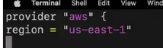
- provide “aws”
- region = “us_ease_1”
Main.tf
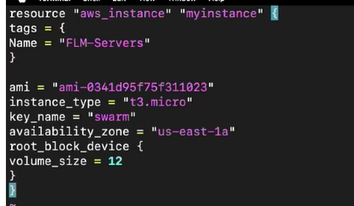
Terraform init ==installation using this cmd
Cat main.tf = to check
Terraform fmt ==uses to to format to correct the indentation
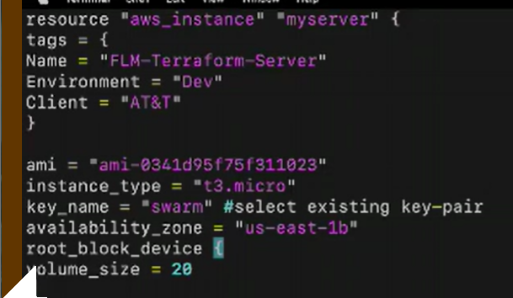

Terraform init
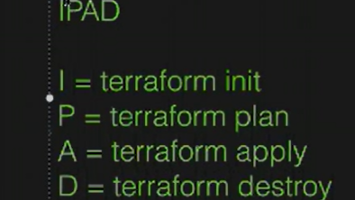
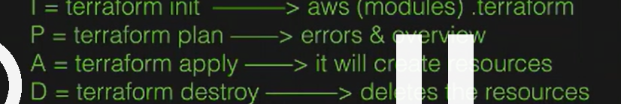

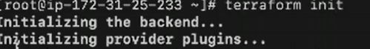

Add iam rore to create
And rerradorm plan
Terraform apply
It will create ec2 instance

Wha t is 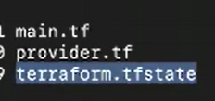

Terraform destroy to uses destroy whet u created to using Files

Terraform class2----------------------------------------------------------------------------------------------------------------

Create a user’s in iam role create user attach pollicises amazon full access click and save and security cdcrate a accessnkey aws config and enter secrete key what we created access key and secret key
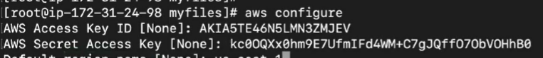
Terraform plan == It’s used to preview changes Terraform will make to your infrastructure
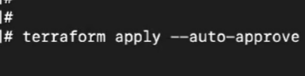
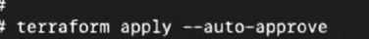
Changes use this cmd without permitions
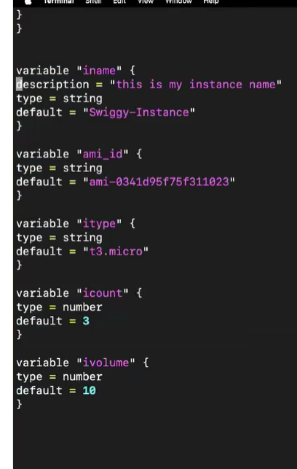
Terra fom =ss=overview
